*Florida International University*

*School of Computing and Information Sciences*

Software Engineering Focus

Feature Document

User Story ID <690 Consult History>

**Name:Bertha M Perez**

**Frank Hernandez**

**Team Member(s): Bertha M Perez**

**Frank Hernandez**

**Project: Snackability 1.0**

**Product Owner(s)**: Dr. Cristina Palacios

**Mentor(s)**:

**Instructor**: Masoud Sadjadi

**User Story Name:** 690 Consult History

### Description:

### As a User I would like to know the snack I consulted before so I can keep learning on healthy snacking

### 

### Acceptance Criteria:

### Have searched snacks before

### 

### 

### 

### Related Tasks:

### 

### 

|  |  |
| --- | --- |
| Use Case Name: Consult History | |
| Participant Actor: User | |
| Entry Condition:   * User must be log in | |
| Exit Condition: User previous searched snacks | |
| **Flow of Events** | |
| **Actor Steps** | **System Steps** |
| 1. User tap History | 2. System open History Page |
|
| **Use Case Exceptions** | |
| **Actor Steps** |  |
|  |  |

**Use Case Diagram <**you can use draw.io**>**

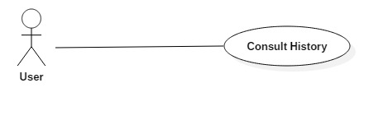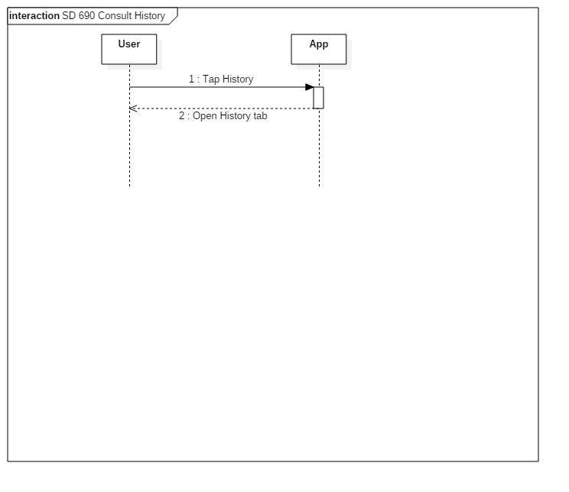

**Sequence Diagram**

**Class Diagram**

**Unit Test**

* Test case ID:
* Description/Summary of Test:
* Pre-condition:
* Expected Results:
* Actual Result:
* Status (Fail/Pass):

**Integration Test**

**Visual User Guide** <like one or two screenshots of the feature. For the hardware project, a photo of device is required>